For each of the days Jan 1 - Dec 31 (skip Feb 29) take the min of the min of all of the stations and for all the years 2005-2014, that's the min for that day (so all that combined results in one data point). Same for max. That's the 2005-2014 range. Then of course you'll also have to go through the 2015 data for the second part of the plot.

--------------------------

I've gotten say 90% there, my graph looks overall correct like many others, but the axis formatting is getting confusing as there are so many knobs it's difficult to know which one's to use or how to use them.

I started with the lecture notes date procedure for the x axis values as shown:

observation_dates = np.arange('2017-01-01', '2017-01-09', dtype='datetime64[D]')

observation_dates = list(map(pd.to_datetime, observation_dates))

The number of x axis ticks is automatically set somehow to 7 ticks, but I can't figure out where or how to change it to 12 ticks. Please provide guidance on how to make this change.

I manually generated x axis labels to replace the datetime label using string formatting to change datetime to "Month", but again the number of ticks is set to 7.

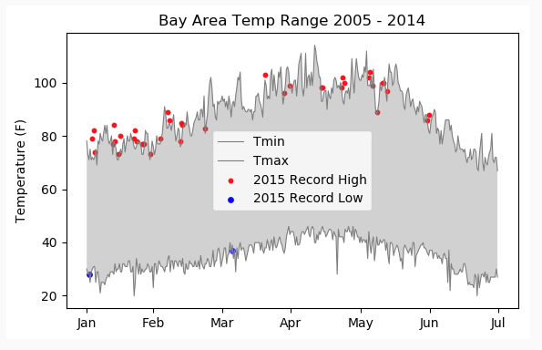

<https://www.coursera.org/learn/python-plotting/peer/QjMGl/plotting-weather-patterns/discussions/threads/ZEzAWwC2EemxYQougy73TA>

---------------------------------

import datetime as dt

m = ['Jan','Feb','Mar','Apr','May','June','July','Aug','Sept','Oct','Nov','Dec']

# This is the vital step. It will create a list of day numbers corresponding to middle of each month i.e. 15(Jan), 46(Feb), ...

ticks = [(dt.date(2017,m,1)-dt.date(2016,12,15)).days for m in range(1,13)]

# It is important to use a non-leap year for this calculation (I used 2017).

# Also, I used (2016,12,15) to substract so that I get middle of each month rather than beginning, it just looks better that way.

ax.set_xticks(ticks)

ax.set_xticklabels(m)

-------------------------------

<https://www.coursera.org/learn/python-plotting/peer/QjMGl/plotting-weather-patterns/discussions/threads/LRDR_J9wEeedFA69v7cROA>

----------------------

<https://www.coursera.org/learn/python-plotting/discussions/weeks/2/threads/7Rh0RAQ1Eee-uQ7R_UJsXg>

